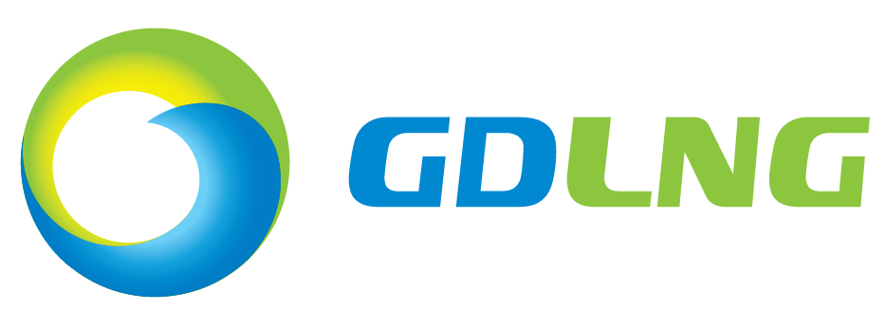
Job Description

岗位说明书

Guangdong Dapeng LNG Company Ltd

广东大鹏液化天然气有限公司

Job Title职位: Assistant Survey Engineer助理测量工程师
JD No.编号:
Department部门: Technical Services 技术服务部
Roles and Accountabilities 工作职责
- Assistant Survey Engineer is under the organization of TS Integrity Management Center, responsible for the technical issues on engineering survey.
助理测量工程师将在公司技术部完整性管理中心工作，负责工程测量方面的技术工作。
- Assistant Survey Engineer reports to Integrity Management Manager.
助理测量工程师将向完整性管理中心经理汇报工作。
Principal activities 基本工作内容
- Involved for the technical requirements of the required survey devices to satisfy the requirements for the future independent engineering survey on site, which includes: GPS coordinate surveying, leveling surveying etc.
参与制定本部门引进测量仪器设备的具体技术要求，满足现场独立进行工程测量的需要，工程测量内容有：GPS坐标测量，水准测量等。
- Responsible for performing coordinate surveying tasks for pipeline protection along the pipe route and at the stations or for other projects.
负责管道沿线或站场因管线保护或其它工程项目需要进行的坐标测量工作。
- Involved for managing the company pipeline coordinate system data and providing accurate and adequate coordinate data together with intelligent inspection demands.
参与管理公司管线坐标系统的数据，并结合智能检测等需求，提供准确合适的坐标数据。
- Responsible for the technical support to coordinate data.
负责对坐标数据提供技术支持
- Responsible for performing other tasks related to survey and coordinate data.
负责完成与测量和坐标数据相关的其他工作。
- Performing other tasks assigned by leader on time
按时完成领导交代的其他工作。
Safety Requirements安全要求
- 自觉遵守公司的安全生产方针/目标；
Consciously abide by the safety operation policies/goals in GDLNG;
- 严格遵守公司的安全生产程序和制度；
Strictly abide by the safety operation procedures and regulations in GDLNG;
- 自觉参与公司的安全文化建设；
Consciously participate in safety culture development companywide;
- 爱岗敬业，自觉参加公司的安全培训和教育，努力掌握和提高岗位技能和安全生产水平；
Be passionate and dedicated to work, consciously participate in company safety trainings and instructions, endeavor to master and improve professional skills and safety operation level;
- 发现风险或隐患，及时汇报；
Report immediately once the potential safety risks are identified;
- 参与公司的应急演练或制度建设；
Participate in company emergency response drills and regulation development;
- 参与或配合事故调查，不瞒/骗/迟报；
Participate in or support the incident investigation and ensure the facticity, accuracy and timeliness;
- 为公司的安全生产，提供合理建议；
Provide constructive proposals for company safety operation;
Competencies & Experience 能力与经验
- Accountability
责任心
- Good team cooperation building
良好的团队协作精神
- Capable of finishing the work within high quality and time limit
能够高质量按时完成工作

- Capable of arranging the work in priority; do well in resolving the problems by team cooperation or employing external resources
能够依据各种事务的轻重缓急安排好工作；善于通过与其他团队的成员进行合作或借助外部资源解决问题
- Good at public communication, capable of effective communication with GDLNG staff, 3rd parties and those with different culture background
良好的人际关系能力，能够与公司内部人员、第三方、不同文化背景的人进行有效交流
Educational Background 教育背景
研究生（地图学与地理信息系统方向）
1.基础编程，能熟练掌握编程语言为优（C++、C#等）
2. GIS软件使用（ARCGIS、MapGIS、SurperMap等任意不限）,GIS二次开发。
3.数据库应用（会数据库编程就更好）。
4.AutoCAD软件基础应用。

研究生（遥感与摄影测量方向）
1.遥感影像处理算法研究。
2.基础编程，能熟练掌握编程语言为优（C++、C#等）
3.数据库应用（会数据库编程就更好）。
4.GIS软件使用（ARCGIS、MapGIS、SurperMap等任意不限）
AutoCAD软件基础应用。

Job Holder ： Date:

Reviewed by DGM: Date:

Approved by Functional VP (or P if no VP): Date:

