Registration process: 1 ~ 8
1. Download Tencent video in app store.
2. Log in to the personal center and fill in personal information.
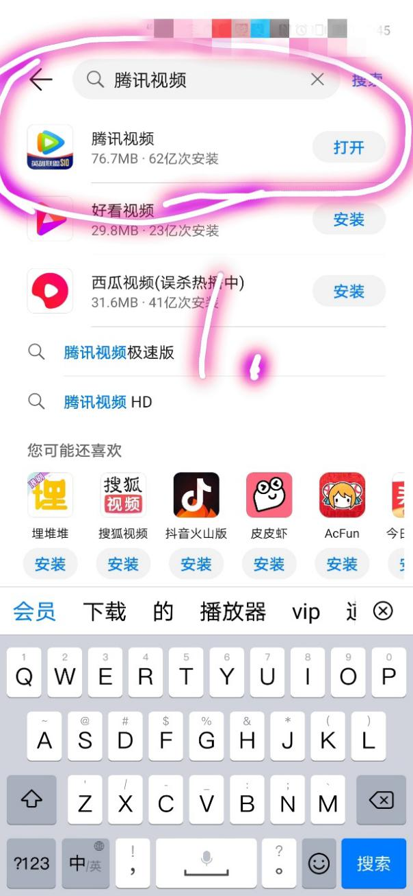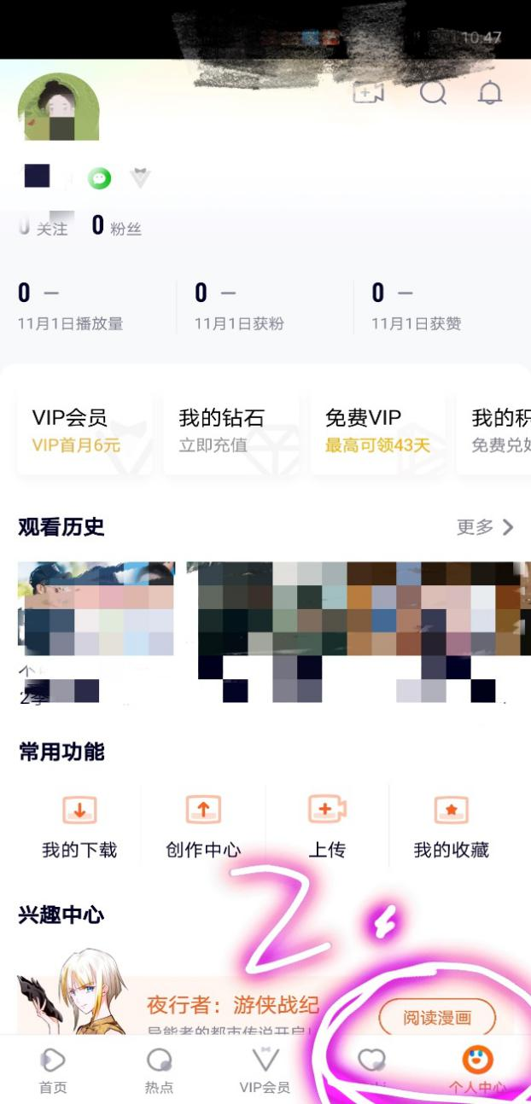

- Upload your video. 4. Click on your profile picture.
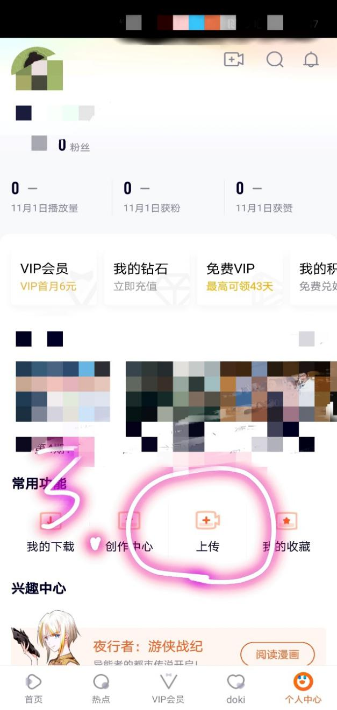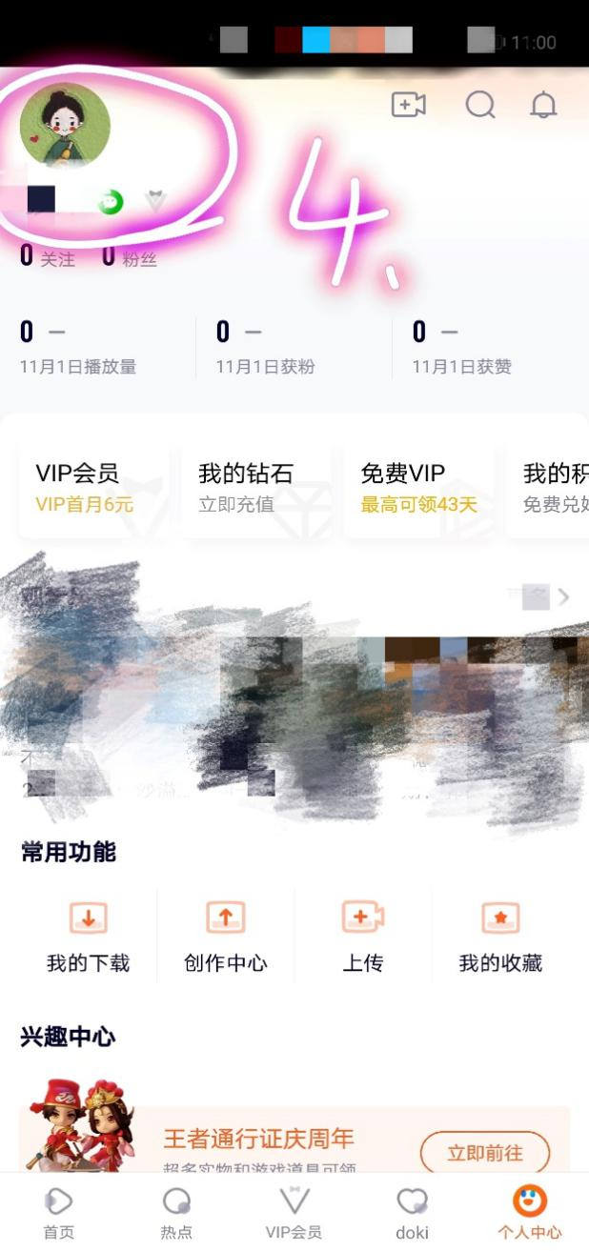

5. You can see that the video is under review.
6. When the video has passed the review, click on it and share it.
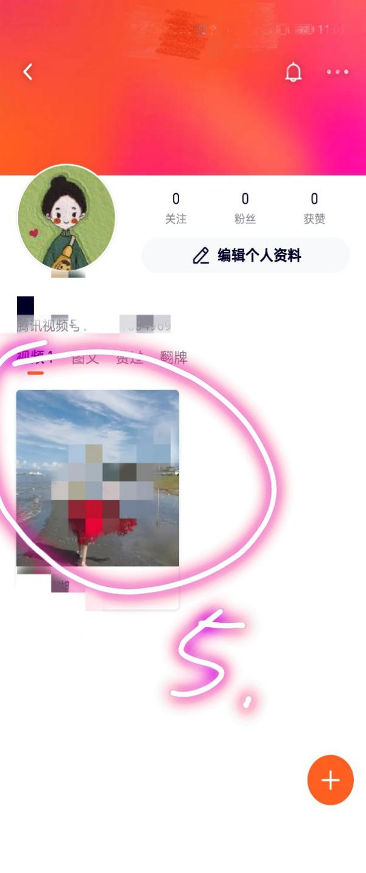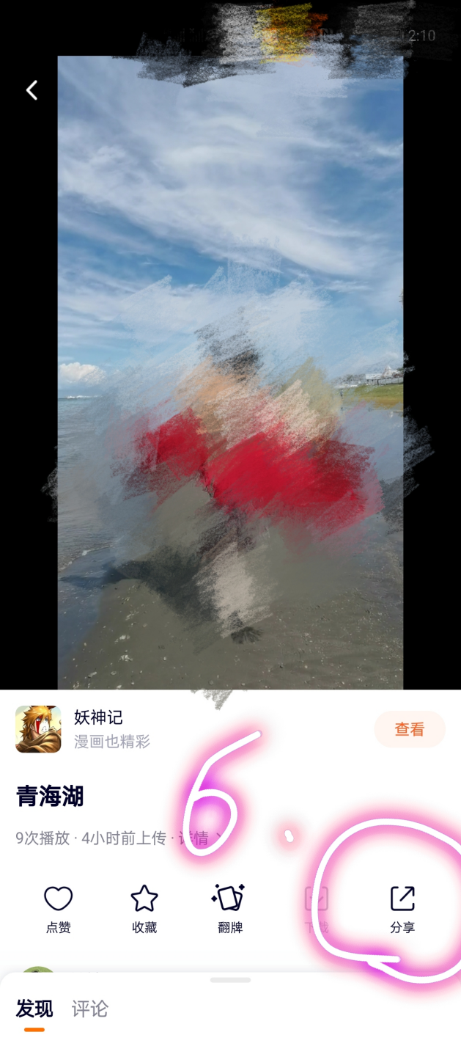

- Click “Copy the link”. Fill in the Word file of the application form and paste your link in the corresponding blank of the form.
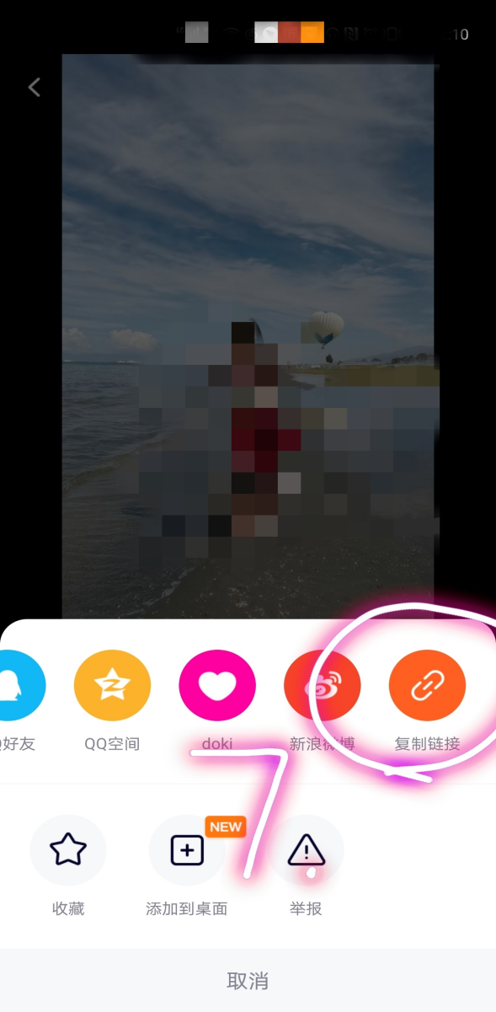
- After completion, submit the form to: xzq@cup.edu.cn no later than Jan 15, 2021
Email title and entry Form Document naming requirements: BJVIDEO-Chinese name-student number, such as "BJVIDEO-Xiaoming-201888888888".

